AutoEmail Update Tests
Tester: Tony Tasker
Date: 7th March 2017
Time: 12:00
PC/Server: TonyTasker-PC
Database: Simmons_V7_Test (Copy of live Simmons and Simmons DB)
Works Summary: N/A
Works Order: N/A
Task: N/A
Notes: These tests were performed using CABS Console (7.0.0.27), Microsoft SQL Server Management Studio. Output to the Results and Messages Output Windows are used to determine the success of the tests. Also the receipt of emails.

Due to issues with MBRs and MBR_IMPKEYS the Booker MBR must be selected carefully. If not then AutoEmailer code will flag up errors. Errors are caused by MBRs not having a unique MBR_IMPKEY.

Purpose

- Test the new autoemail diagnostic table function works

- Test removed of the EmailAddressType code from the subject line of the email

- Check additional debugging information is working

Pre-Test Setup
No | Task | Tester | Pass | Notes
1 | In X CABS Config, Section  Set DebugFlag=1  In section CABS_AUTO_EMAIL_FUNCS_Trigger  Set DebugFlag=1 | TT
2 | In X CABS Config, Section AEFCON change setting  Frequency=D:1;H:0;M:0;W:1;S:0;T:0730;L:B4;  to  FFrequency=D:1;H:0;M:0;W:1;S:0;T:0730;L:B4;  Add  Frequency=D:0;H:0;M:1;W:1;L:CR; | TT |  | Changing Key name from Frequency to FFrequency keeps the original setting visible but enables a betting setting to be used for testing purposes.
3 | In X CABS Config, Section AEFCON change settings to those indicated below:  EnabledB=I:1;U:1;D:0  EnabledC=I:1;U:1;D:0 | TT

Post-Test Setup
No | Task | Tester | Pass | Notes
1 | Reverse any Config Changes in X CABS Config | TT

Tests

Test utf_AutoEmailStatus for All Functions
No | Test | Tester | Pass | Notes
1 | In SSMS open a new query to database | TT
2 | Run query:  SELECT * FROM [dbo].utf_AutoEmailStatus('') | TT |  | Results displayed as per figure below (including verbose reasons explaining whether an email is able to be transmitted or not).

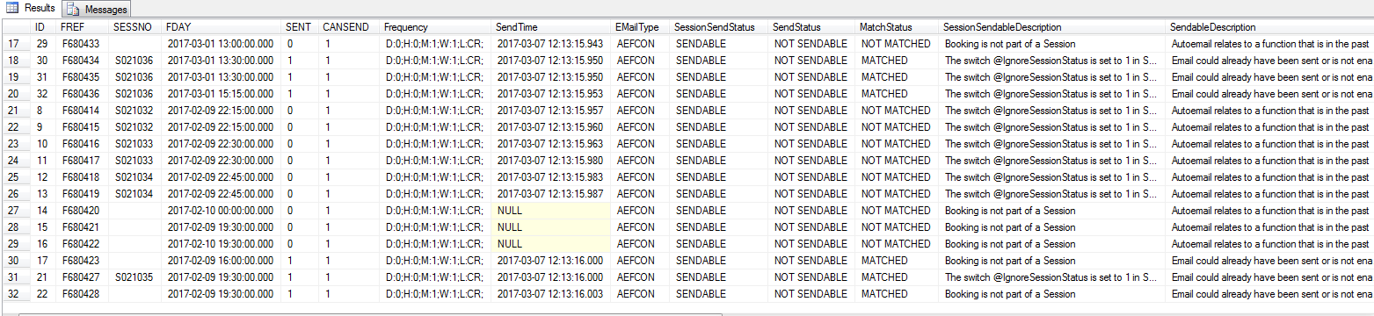
Figure 1 - Output from utf_AutoEmailStatus('')

Test utf_AutoEmailStatus for a Specific Function
No | Test | Tester | Pass | Notes
1 | In SSMS open a new query to database | TT
2 | Run query:  SELECT * FROM [dbo].utf_AutoEmailStatus('F680428') | TT |  | Results displayed as per figure below (including verbose reasons explaining whether an email is able to be transmitted or not).

Figure 2 - Output from utf_AutoEmailStatus('F680428')

Check Email Subject Line No Longer Contains EmailAddressType

No | Test | Tester | Pass | Notes
1 | In CABS Console, open the booking diary.  Select an appropriate date to add Function Bookings.  Selected 8th March and created a new function using the console  Room: MR07  Covers: 3  Booker: Mrs Tracey Trevallion (M072853)  Status: PROVNL  Time: 15:00-16:00  Chose MBR M077711 (Bob Jones)  Function was F680441.  Added Extras “Biscuits” (3 Covers) | TT
2 | Check the email is transmittable  Run query  SELECT * FROM [dbo].utf_AutoEmailStatus('F680441') | TT |  | For FREF F680441:  SENT should be 0,  CANSEND should be 1,  SessionSendStatus should be SENDABLE,  SendStatus should be SENDABLE,  MatchStatus should be MATCHED
3 | Process the AutoEmail  EXEC CABS_AUTO_EMAIL_FUNCS_SESS_CHECK | TT |  | Emails delivered as per Figure 3. Note the Subject line compared to Figure 4 which is an email before the change.

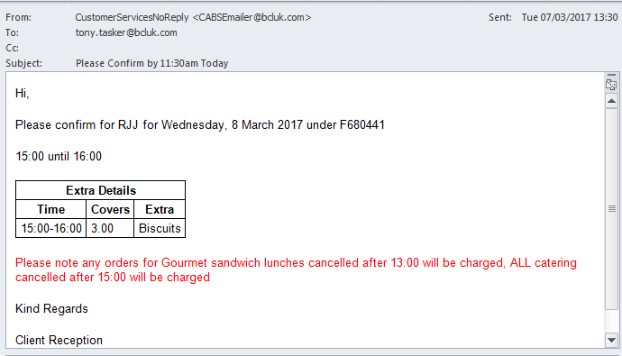
Figure 3 – 1st Confirmation Email Sent (AEFCON)
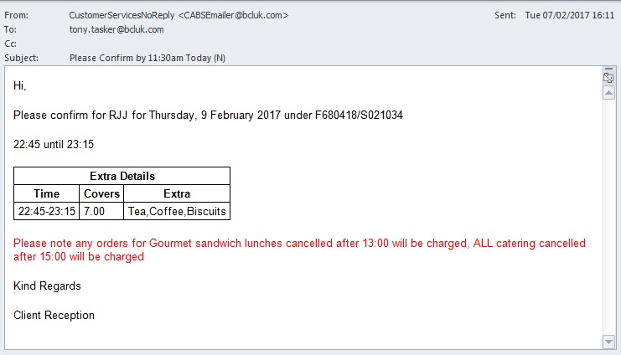
Figure 4 – Old Email with EMailAddressType on Subject Line

Ensure Additional Diagnostic Information is Displaying

No | Test | Tester | Pass | Notes
1 | In SSMS using the Messages tab from the previous test check the diagnostic messages displayed | TT |  | Ensured new messages were displayed as per Figures 5, 6 and 7

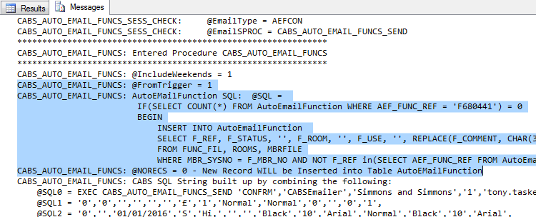
Figure 5 – Additional AutoEmail Diagnostic Information – Part 1

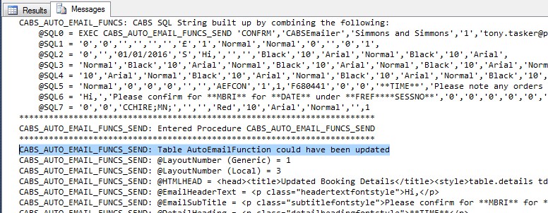
Figure 6 – Additional AutoEmail Diagnostic Information – Part 2

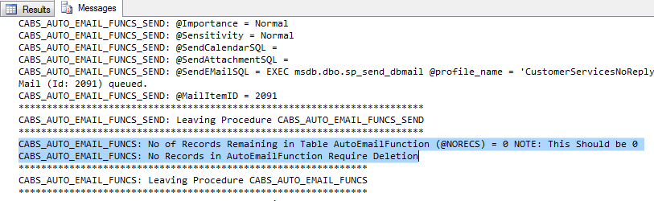
Figure 7 – Additional AutoEmail Diagnostic Information – Part 3

